Lab 7 Analysis Assignment

Diptesh Kanojia (154054002)

A Heuristic based stop / delay has been applied in the lab assignment code. It lets the switch go undetected for the first 130 ms in the cycle.

Then the heuristic is to use Semaphores and add delays between them using variable ui32Period i.e. has been assigned the value (SysCtlClockGet()/100), which will make the first semaphore execution of Switch Semaphore (SWITCHSem) immediately, if tickCount == 1, which increments every time with the cycle. The first time period is 100 ms, then the second delay is 200 ms, and the third delay is 300 ms.

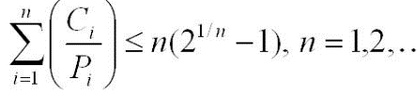

The priorities based on Rate Monotonic Algorithm are:

1. SWITCHSem (Switch)
2. ADCSem (ADC – Joystick)
3. GLCDSem (GLDC – Display).

This makes sure the code runs smoothly, and detects both switch and joystick while displaying the images on GLCD.